DATA ANALYTICS CAPSTONE PROJECT
Among the many factors that may influence childhood anemia, household wealth index and maternal educational level are two of the most important socioeconomic indicators available in the Nigeria Demographic and Health Survey (NDHS). Household wealth reflects a family's ability to provide nutritious food, access healthcare services, maintain good sanitation, and meet other basic needs that contribute to a child's health. Maternal educational level reflects a mother's knowledge, health literacy, and ability to make informed decisions about nutrition, hygiene, healthcare utilization, and child-feeding practices.
Examining these two variables together allows the study to determine whether economic status, maternal education, or both are associated with childhood anemia. This is important because the appropriate public health response may differ depending on the findings. If household wealth shows a stronger association, interventions such as poverty alleviation, food assistance, or nutrition support may be prioritized. If maternal education has a stronger association, policies that strengthen female education and health education programs may have a greater impact.
Focusing on them provides a manageable scope for analysis while addressing a question that is relevant to policymakers, healthcare professionals, and organizations working to reduce childhood anemia in Nigeria.

RESEARCH QUESTIONS.
This study seeks to answer the following research questions:
- How does a mother's educational level relate to child anemia among children aged 0–59 months in Nigeria?
- How does household wealth index relate to child anemia among children aged 0–59 months in Nigeria?

Methodology
1. Variables Used
The analysis focused on three variables extracted from the 2018 Nigeria Demographic and Health Survey (NDHS):

Variable | Reason for Selection
Mother's Educational Level | It represents the mother's level of formal education and serves as an indicator of health literacy and socioeconomic status.
Household Wealth Index | It represents the economic status of the household and provides insight into the family's access to healthcare and nutrition.
Child Anemia Status | It serves as the outcome (dependent) variable, indicating whether a child is not anemic or has mild, moderate, or severe anemia.

2. Data Cleaning
Data cleaning was performed before analysis to improve data quality and ensure reliable results.
The following steps were carried out:
- The dataset was imported into MySQL for cleaning and analysis.
- Missing values were assessed using SQL queries.
- Blank entries stored as empty strings ('') in the child_anemia column were identified and converted to SQL NULL values to represent missing observations correctly.
- Records with missing child anemia status were excluded from the analytical dataset by creating a cleaned view (clean_anemia) containing only observations with recorded anemia status.
- The variables mother_education and wealth_index contained no missing values or inconsistent category names.
- No outlier treatment was required because all variables used in the analysis were categorical rather than numerical.
3. Tools Used
Three tools were used throughout the analysis.
MySQL
MySQL was used for:
- Importing the dataset
- Data cleaning
- Identifying missing values
- Checking category consistency
- Generating frequency distributions
- Producing cross-tabulations and percentage summaries
MySQL was selected because it provides efficient querying and data management capabilities for large datasets.

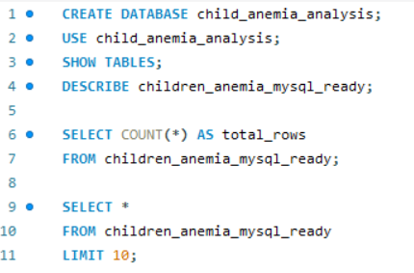
Fig 1.1 Creating the database and calling the table in the database
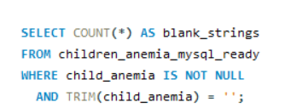
Fig 1.2 Filling empty cells with NULL value

Power BI
Power BI was used to visualize the findings through interactive charts and dashboards. It enabled the presentation of relationships between maternal education, household wealth, and child anemia in a clear and accessible format.
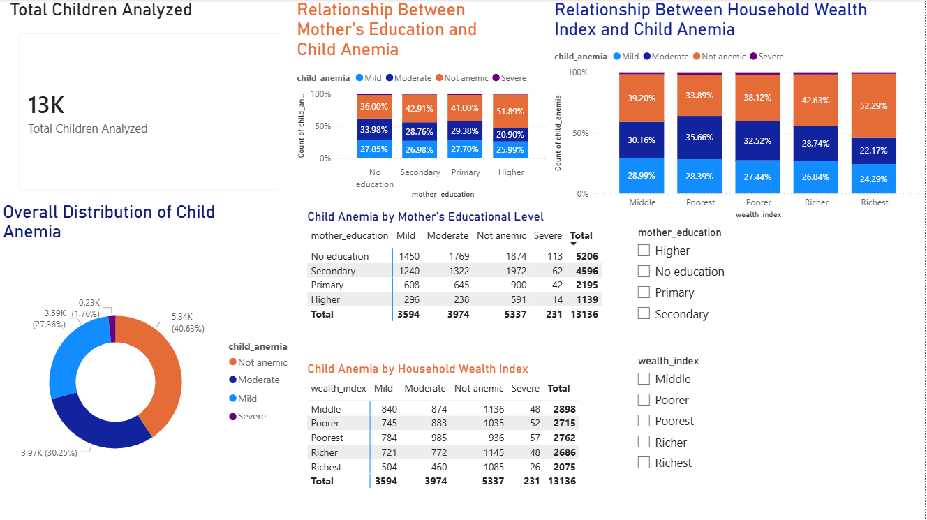
Fig 1.2 Full PowerBI Dashboard

Microsoft Excel
Excel was used for the initial inspection of the dataset before importing it into MySQL.
4. Analytical Techniques
The analysis employed descriptive statistical techniques appropriate for categorical data.
Frequency Distribution
Frequency distributions were used to summarize:
- Mother's educational level
- Household wealth index
- Child anemia status
This provided an overview of the composition of the dataset.
Cross-Tabulation
Cross-tabulation was used to compare child anemia categories across:
- Mother's educational level
- Household wealth index
This technique made it possible to examine how the distribution of child anemia varied between different socioeconomic groups.
Percentage Analysis
Row percentages were calculated within each education level and wealth category. This allowed meaningful comparisons despite differences in group sizes and highlighted the relative proportion of children in each anemia category.
No regression or correlation analysis was performed because the objective was to describe and compare categorical variables rather than model causal relationships.

Findings
Research Question 1
How does a mother's educational level relate to child anemia?
The analysis indicates a positive relationship between maternal education and child health outcomes.
Children whose mothers had higher education recorded the highest proportion of non-anemic cases (51.89%), while children whose mothers had no formal education recorded the lowest proportion (36.00%).
This pattern suggests that higher maternal education is associated with a greater likelihood of children being free from anemia. Mothers with higher education may possess better health knowledge, improved nutritional practices, and greater utilization of healthcare services, all of which contribute to improved child health.
Supporting Visuals:
- 100% Stacked Column Chart: Relationship Between Mother's Education and Child Anemia
- Matrix Table: Mother's Education × Child Anemia

How does household wealth index relate to child anemia?
The analysis also revealed a positive association between household wealth and child anemia status.
Children from the richest households recorded the highest proportion of non-anemic cases (52.29%), whereas children from the poorest households recorded the lowest proportion (33.89%).
This suggests that children living in wealthier households are more likely to have better nutritional status and improved access to healthcare, resulting in lower levels of anemia.
Supporting Visuals:
- 100% Stacked Column Chart: Relationship Between Household Wealth Index and Child Anemia
- Matrix Table: Household Wealth Index × Child Anemia

Conclusion
This study examined the relationship between maternal educational level, household wealth index, and childhood anemia among Nigerian children aged 0–59 months using data from the 2018 Nigeria Demographic and Health Survey.
The findings indicate that both maternal education and household wealth are associated with childhood anemia status. Children whose mothers had higher levels of education and those living in wealthier households were more likely to be non-anemic than children whose mothers had little or no formal education or who lived in poorer households.
Although this analysis does not establish cause and effect, it highlights important socioeconomic factors that are associated with child health. The findings suggest that policies aimed at improving female education and reducing household poverty may contribute to better child nutrition and lower rates of childhood anemia.

